**React**

**9. ReactJS-HOL**

**Code:**

**//ListofPlayers.js**

function ListofPlayers() {

const players = [

{ name: 'Jack', score: 50 },

{ name: 'Michael', score: 70 },

{ name: 'John', score: 40 },

{ name: 'Ann', score: 61 },

{ name: 'Elisabeth', score: 61 },

{ name: 'Sachin', score: 95 },

{ name: 'Dhoni', score: 100 },

{ name: 'Virat', score: 84 },

{ name: 'Jadeja', score: 64 },

{ name: 'Raina', score: 75 },

{ name: 'Rohit', score: 80 }

];

const playersBelow70 = players.filter(player => player.score < 70);

return (

<>

<h1>List of Players</h1>

<ul>

{players.map((player, index) => (

<li key={index}>

Mr. {player.name} {player.score}

</li>

))}

</ul>

<h1>List of Players having Scores Less than 70</h1>

<ul>

{playersBelow70.map((player, index) => (

<li key={index}>

Mr. {player.name} {player.score}

</li>

))}

</ul>

</>

);

}

export default ListofPlayers;

**//IndianPlayers.js**

function IndianPlayers() {

const indianPlayers = ['Sachin', 'Dhoni', 'Virat', 'Rohit', 'Yuvraj', 'Raina'];

const [firstPlayer, secondPlayer] = indianPlayers;

console.log('Demonstrating Destructuring:', firstPlayer, secondPlayer);

const oddPlayers = indianPlayers.filter((_, index) => index % 2 === 0);

const evenPlayers = indianPlayers.filter((_, index) => index % 2 !== 0);

const positionWords = ['First', 'Second', 'Third', 'Fourth', 'Fifth', 'Sixth'];

const T20players = ['First Player', 'Second Player', 'Third Player'];

const RanjiTrophy = ['Fourth Player', 'Fifth Player', 'Sixth Player'];

const mergedPlayers = [...T20players, ...RanjiTrophy];

return (

<>

<h1>Odd Players</h1>

<ul>

{oddPlayers.map((player, index) => (

<li key={index}>

{positionWords[index * 2]} : {player}{(index * 2) + 1}

</li>

))}

</ul>

<h1>Even Players</h1>

<ul>

{evenPlayers.map((player, index) => (

<li key={index}>

{positionWords[(index * 2) + 1]} : {player}{(index * 2) + 2}

</li>

))}

</ul>

<h1>List of Indian Players Merged:</h1>

<ul>

{mergedPlayers.map((player, index) => (

<li key={index}>

Mr. {player}

</li>

))}

</ul>

</>

);

}

export default IndianPlayers;

**//App.js**

import ListofPlayers from './ListofPlayers';

import IndianPlayers from './IndianPlayers';

function App() {

const flag = true;

return (

<div className="App">

<header className="App-header">

{flag ? <ListofPlayers /> : <IndianPlayers />}

</header>

</div>

);

}

export default App;

**Output:**

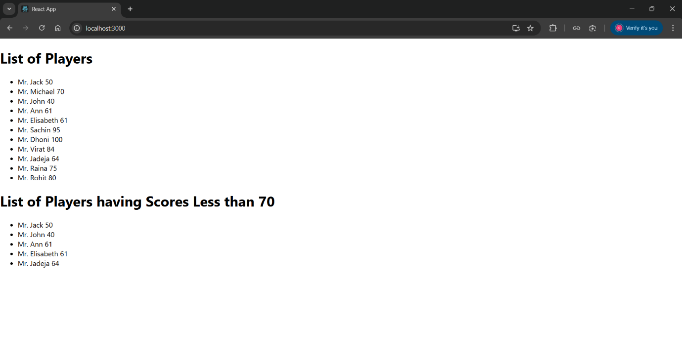

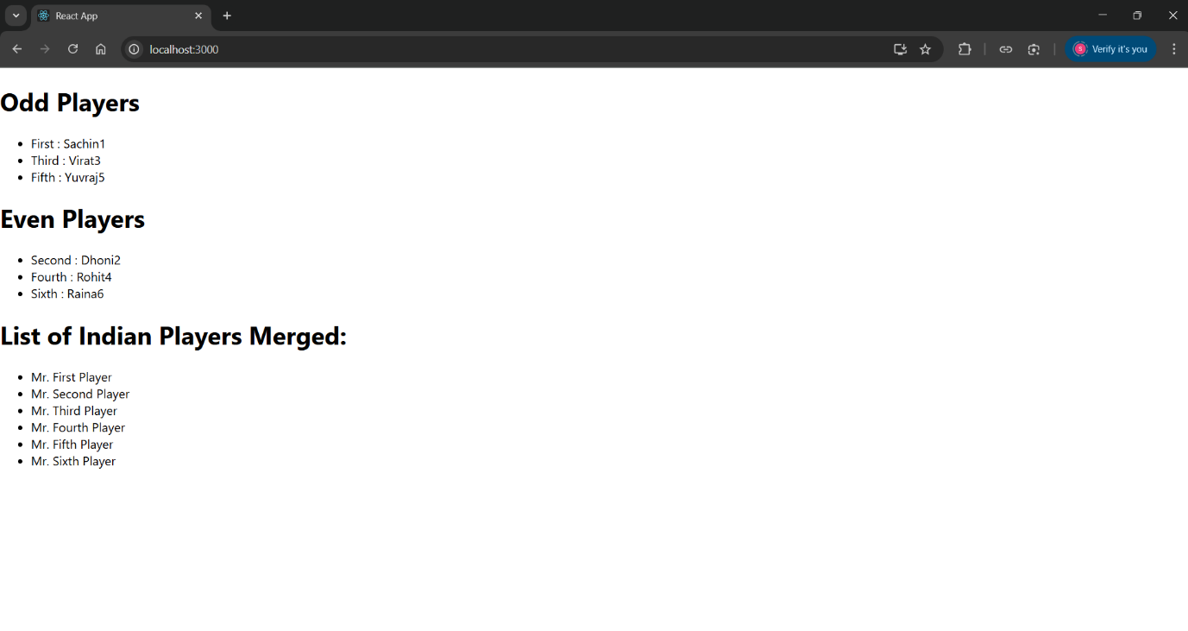**10. ReactJS-HOL**

**Code:**

**/*App.css*/**

.App {

text-align: center;

font-family: Arial, sans-serif;

padding: 20px;

}

.office-list {

display: flex;

flex-wrap: wrap;

justify-content: center;

gap: 24px;

}

.office-card {

background: #fff;

border: 1px solid #eee;

border-radius: 8px;

width: 250px;

padding: 16px;

box-shadow: 0 2px 8px rgba(0,0,0,0.07);

}

.office-img {

width: 100%;

height: 150px;

object-fit: cover;

border-radius: 5px;

margin-bottom: 12px;

}

**//App.js**

import './App.css';

const offices = [

{

id: 1,

name: "Downtown View",

rent: 55000,

address: "101 Main St, Downtown",

image: "https://images.unsplash.com/photo-1506744038136-46273834b3fb?auto=format&fit=crop&w=500&q=80"

},

{

id: 2,

name: "Uptown Plaza",

rent: 75000,

address: "202 Uptown Rd, City Center",

image: "https://images.unsplash.com/photo-1464983953574-0892a716854b?auto=format&fit=crop&w=500&q=80"

},

{

id: 3,

name: "Central Hub",

rent: 65000,

address: "303 Central Blvd, Midtown",

image: "https://images.unsplash.com/photo-1515378791036-0648a3ef77b2?auto=format&fit=crop&w=500&q=80"

},

{

id: 4,

name: "Budget Space",

rent: 40000,

address: "404 Low St, Suburbia",

image: "https://images.unsplash.com/photo-1470770841072-f978cf4d019e?auto=format&fit=crop&w=500&q=80"

}

];

const getRentColor = (rent) => (rent < 60000 ? 'red' : 'green');

function App() {

return (

<div className="App">

<h1>Office Space Rental App</h1>

<div className="office-list">

{offices.map(office => (

<div className="office-card" key={office.id}>

<img src={office.image} alt={office.name} className="office-img" />

<h2>{office.name}</h2>

<p><strong>Address:</strong> {office.address}</p>

<p>

<strong>Rent:</strong>{' '}

<span style={{ color: getRentColor(office.rent) }}>

₹{office.rent}

</span>

</p>

</div>

))}

</div>

</div>

);

}

export default App;

**Output:**

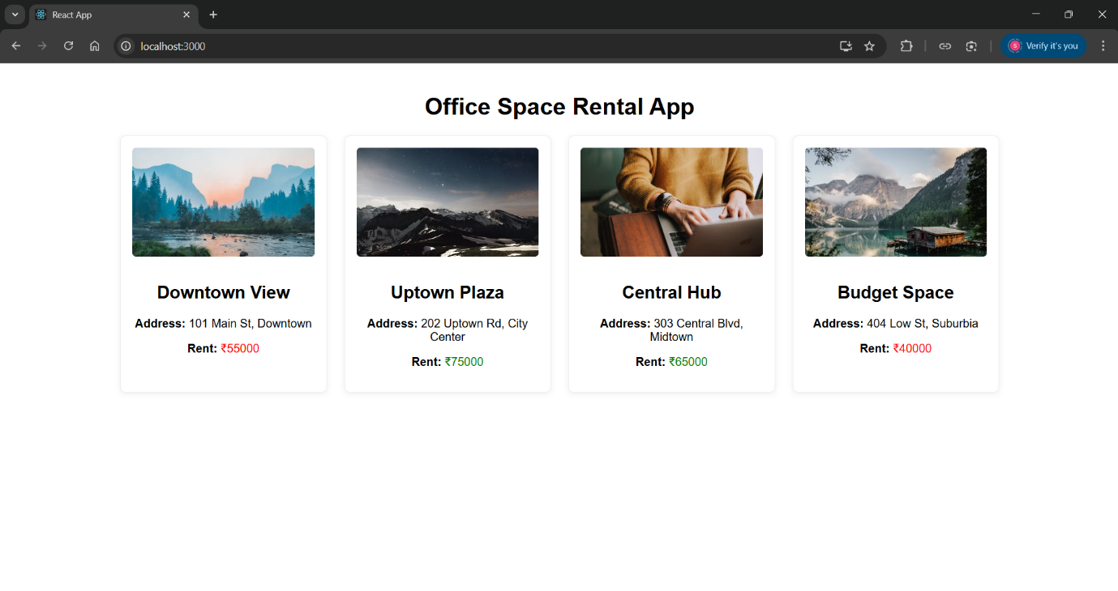

**11. ReactJS-HOL**

**Code:**

**/*App.css*/**

.App {

text-align: center;

}

.App-logo {

height: 40vmin;

pointer-events: none;

}

@media (prefers-reduced-motion: no-preference) {

.App-logo {

animation: App-logo-spin infinite 20s linear;

}

}

.App-header {

background-color: #282c34;

min-height: 100vh;

display: flex;

flex-direction: column;

align-items: center;

justify-content: center;

font-size: calc(10px + 2vmin);

color: white;

}

.App-link {

color: #61dafb;

}

@keyframes App-logo-spin {

from {

transform: rotate(0deg);

}

to {

transform: rotate(360deg);

}

}

**//App.js**

import React, { useState } from 'react';

import CurrencyConvertor from './CurrencyConvertor';

function App() {

const [counter, setCounter] = useState(5);

const sayHello = () => {

window.alert('Hello! Member1');

};

const increment = () => {

setCounter(prev => prev + 1);

sayHello();

};

const decrement = () => setCounter(prev => prev - 1);

const sayWelcome = (msg) => {

window.alert(msg);

};

const handleClick = () => {

window.alert('I was clicked');

};

return (

<div style={{ margin: '32px' }}>

<div>{counter}</div>

<button onClick={increment}>Increment</button>

<br />

<button onClick={decrement}>Decrement</button>

<br />

<button onClick={() => sayWelcome('welcome')}>Say welcome</button>

<br />

<button onClick={handleClick}>Click on me</button>

<br /><br />

<CurrencyConvertor />

</div>

);

}

export default App;

**Output:**

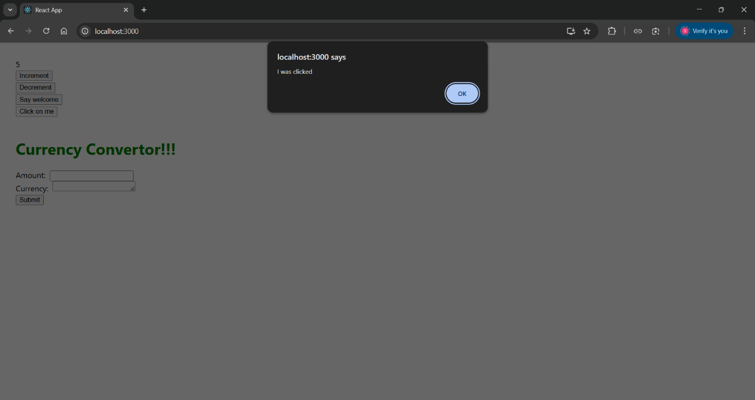

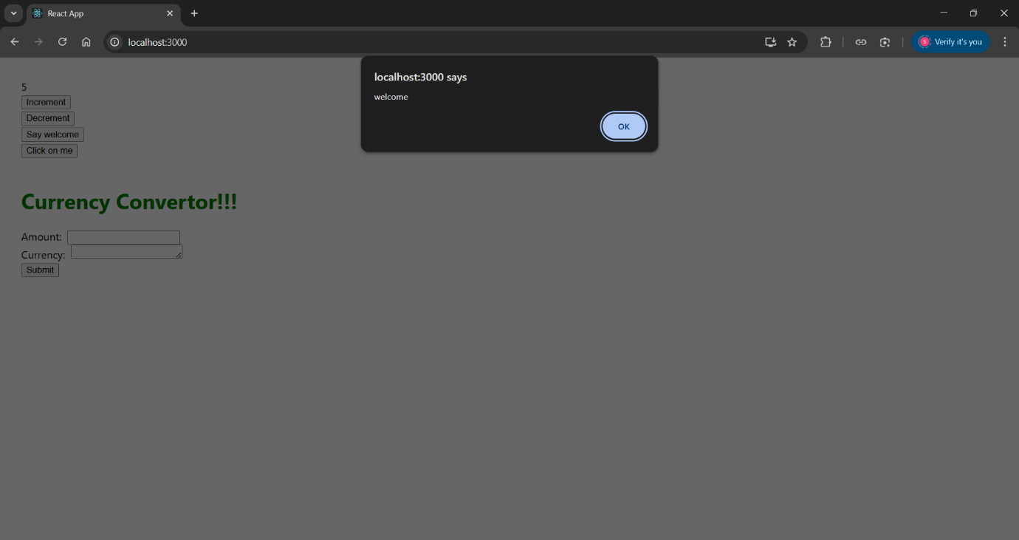

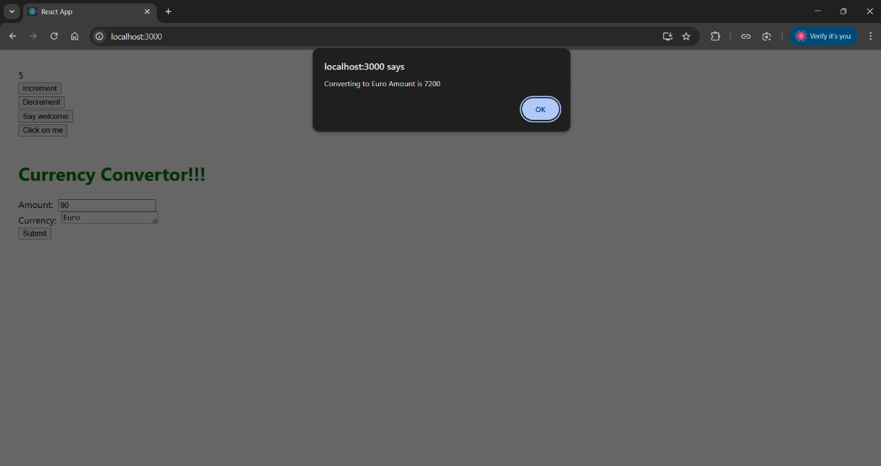

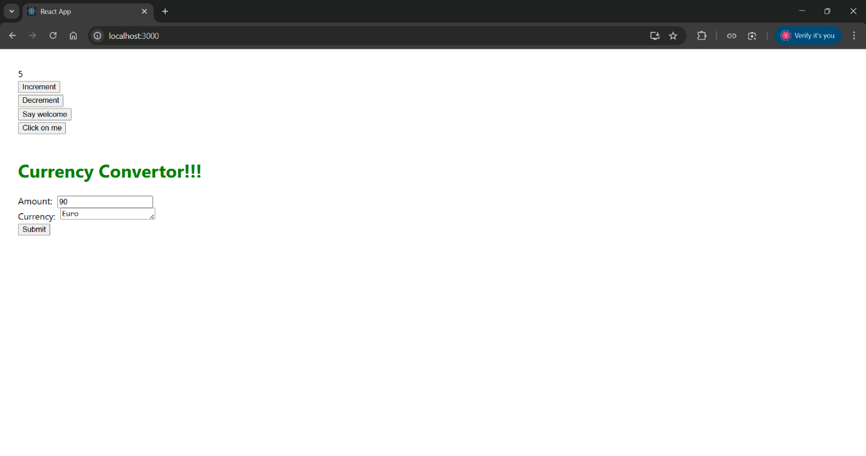**12. ReactJS-HOL**

**Code:**

**//App.js**

import React, { useState } from 'react';

function GuestPage({ onLogin }) {

return (

<div style={{ textAlign: 'center', marginTop: '100px' }}>

<h1>Please sign up.</h1>

<button onClick={onLogin}>Login</button>

</div>

);

}

function UserPage({ onLogout }) {

return (

<div style={{ textAlign: 'center', marginTop: '100px' }}>

<h1>Welcome back</h1>

<button onClick={onLogout}>Logout</button>

</div>

);

}

function App() {

const [loggedIn, setLoggedIn] = useState(false);

return loggedIn

? <UserPage onLogout={() => setLoggedIn(false)} />

: <GuestPage onLogin={() => setLoggedIn(true)} />;

}

export default App;

**Output:**

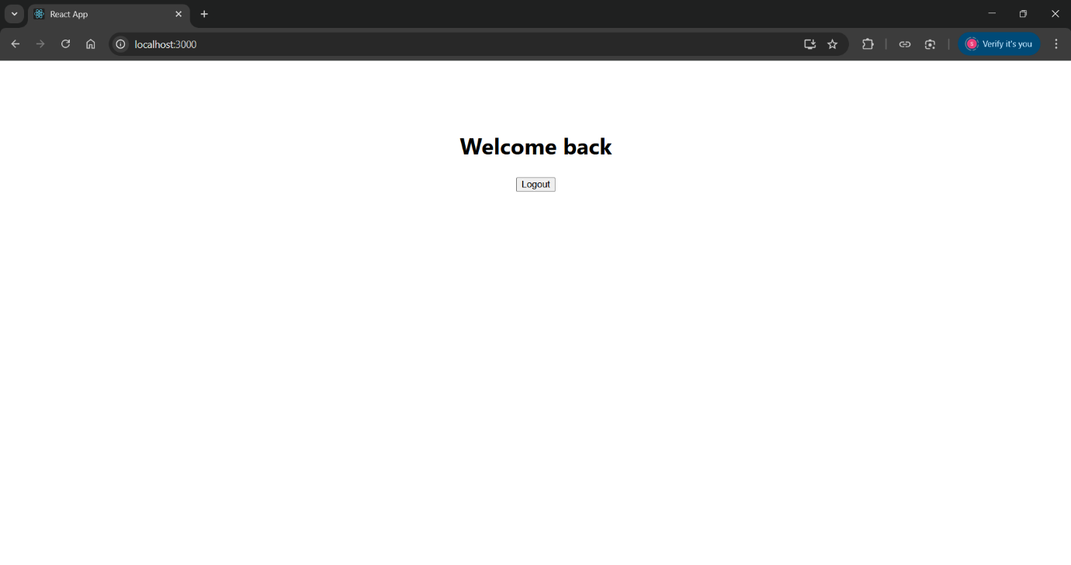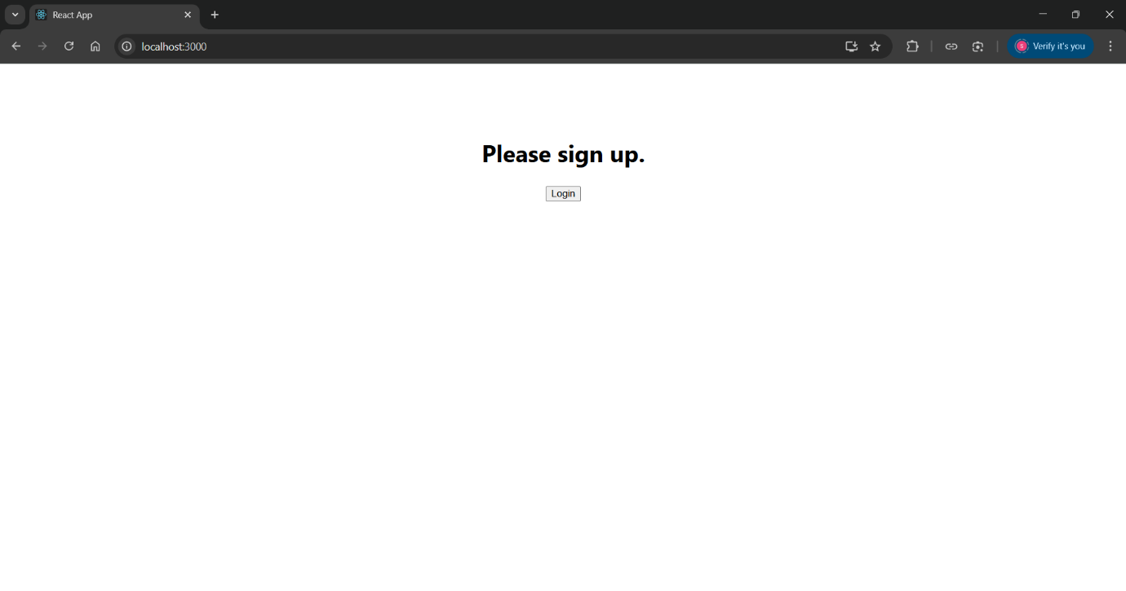

**13. ReactJS-HOL**

**Code:**

**//books.js**

export const books = [

{ id: 101, bname: 'Master React', price: 670 },

{ id: 102, bname: 'Deep Dive into Angular 11', price: 800 },

{ id: 103, bname: 'Mongo Essentials', price: 450 }

];

**//BlogDetails.js**

import React from "react";

export default function BlogDetails() {

return (

<div>

<b style={{ fontSize: '1.5em' }}>React Learning</b>

<div>

<b>Stephen Biz</b>

<div>Welcome to learning React!</div>

</div>

<h2>Installation</h2>

<p>

<b>Schwezdenier</b>

<div>You can install React from npm.</div>

</p>

</div>

);

}

**//BookDetails.js**

import React from "react";

export default function BookDetails(props) {

return (

<ul>

{props.books.map((book) => (

<div key={book.id}>

<h3>{book.bname}</h3>

<h4>{book.price}</h4>

</div>

))}

</ul>

);

}

**//CourseDetails.js**

import React from "react";

export default function CourseDetails() {

return (

<div>

<b style={{ fontSize: '1.5em' }}>Angular</b>

<div>4/5/2021</div>

<br/>

<b style={{ fontSize: '1.5em' }}>React</b>

<div>6/3/2021 </div>

</div>

);

}

**/*App.css*/**

.mystyle1, .st2 {

min-width: 300px;

text-align: left;

margin: 10px 20px;

}

.vl {

border-left: 4px solid green;

height: 350px;

margin-top: 20px;

}

h1 {

font-size: 2em;

margin-bottom: 20px;

}

**//App.js**

import React from "react";

import "./App.css";

import { books } from "./books";

import BookDetails from "./BookDetails";

import BlogDetails from "./BlogDetails";

import CourseDetails from "./CourseDetails";

function App() {

const show = "all";

let bookdetSection = (show === "all" || show === "book") ? <BookDetails books={books} /> : null;

let blogSection = (show === "all" || show === "blog") ? <BlogDetails /> : null;

let courseSection = (show === "all" || show === "course") ? <CourseDetails /> : null;

return (

<div>

<div style={{ display: 'flex', justifyContent: 'center', marginTop: "60px" }}>

<div className="mystyle1">

<h1>Course Details</h1>

{courseSection}

</div>

<div className="vl"></div>

<div className="st2">

<h1>Book Details</h1>

{bookdetSection}

</div>

<div className="vl"></div>

<div className="st2">

<h1>Blog Details</h1>

{blogSection}

</div>

</div>

</div>

);

}

export default App;

**Output:**

